E-Commerce Database Project Documentation
Schema Design

1.Database Creation

Name of Database : ecommerce_db

This image show how to connect database by using postgresSQL.

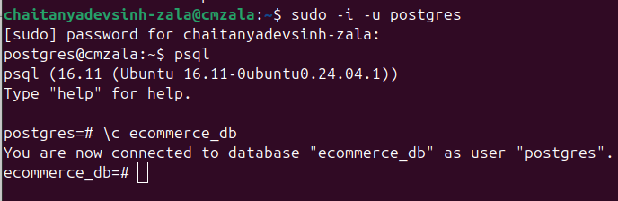

In this image used \l command it’s show List of databaases in postgres.

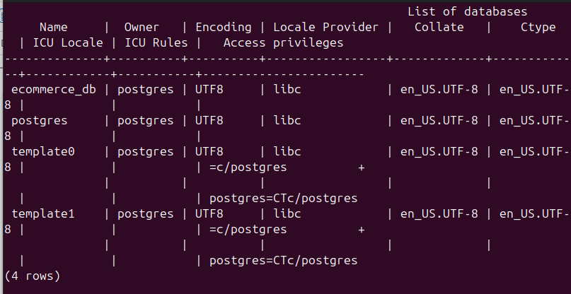

2.Table Creation

The following table use for created table to store e-commerce data.

